5. PROJECT PLANNING

PROJECT PLANNING

The most critical phase of any project is planning. Grievances redressal systems have become increasingly important during past one or two decades. First, information (i.e. grievance) is now recognized as a vital resource. Second, more and more technical resources are committed to these redressal systems. Third, there is growing need for formal long-range planning with grievances redressal systems.

5.1 Project Scope

The scope of the project can be described in the following manner:

Designing a mechanism which can act as a platform for students to register their problems or grievances.

Designing a user friendly graphical user interface -
for students to enter their personal information (name,class,problem/grievance,).
for administrator to verify,classify,allocate complaints.
for committee members to respond complaints or forward them to any other committee member.

5.2 Development Plan

The design and implementation of this project has been carried out in a completely step-by-step manner.
- Questionnaire
- Survey
- Design Document
- Software Requirement Specification
- Coding
- Testing
- Project Report

5.3 Team Structure

5.3 Team Structure

Student Support System,IIPS
(Project)

Internal Guide
(Mr. Shaligram Prajapat)

Additional Guide
(Mr. Sunny Raikwar)

Software Developers
(Vaibhav Sabharwal)
(Varun Wadhwani)

5.4 Project Deliverables

Project Report
Project report provides an introduction to current system and system to be built. It gives the brief knowledge of current system.

Project Documentation
A complete documentation is given in the form of SRS. Software Requirement Specification (SRS) which provides an introduction of the current system and the system to be built. This overview includes the purpose of SRS and a brief knowledge of the current system. The overview also provided an introduction of the proposed system.

/* Pre- Installation
The installation of prior software’s like Microsoft Access. These software are essential for the smooth and proper running of project. */

5.5 Gantt chart

Gantt chart is a time-phased bar chart display that lists tasks or activities along the left side and a corresponding bar for each task. The length of the bar represents the duration of the activity. This scheduling tool used to display the status of a project’s tasks. The Gantt chart shows each task’s duration as a horizontal line. The ends of the lines correspond to the task’s start and end dates.

/*
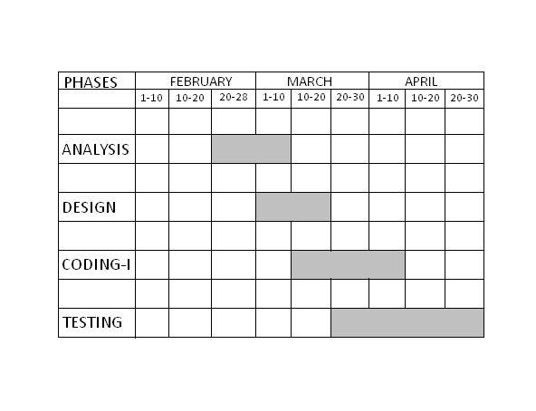*/

6. DESIGN

6

DESIGN

6.1 Logical Design

Logical design describes the functions required by a system, which are:

- Student registration
- Complaint registration
- Proof uploading
- Reference number generation
- Complain management
- Complaint status retrieval
- Reports generation

The following are the objectives of Logical Design :

- Analyze timely complaint solving, student’s satisfaction(through feedback) and oversee committee members.
- The ER Diagrams constructed by keeping in my general entries related to student ,administrator and committee members and their relation with other entities.
- Transformation of Conceptual Data Model into a Relational Model with data specifications.

6.1.1 Entities Definitions

Entities are the principle data object about which information is to be collected. Entities are either concrete or abstract, such as person, places, things, or events, which have relevance to the database.
The following is the list of entities that have been identified during analysis:-

- Name: Student
Definition: their can be large number of students
Identifier: student_id

- Name: Administrator
Definition: their will be one administrator
Identifier: admin_id

- Name: Committee Member
Definition: their will be one committee member for each type of complaint
Identifier: member_id

- Name: Complaint
Definition: their will be complaints registered by students
Identifier: complaint_id

- Name: Account
Definition: account will be created by students
Identifier: account_id

- Name: Proof
Definition: proof will be uploaded by student
Identifier: student_id

- Name: Reports
Definition: periodical reports will be generated by administrator and committee members
Identifier: admin_id(for administrator)
member_id(for committee member)

- Name: Solution
Definition: solution will be given by committee member
Identifier: student_id

6.1.2 Attribute Definitions

The attributes that are identified as part of the entities are listed along with their description.

1. Name of Entity: Student

Attribute | Datatype | Description | Length | Allow null
student_id | varchar | Student’s  Roll no./Enrollment no. | 50 | no
name | varchar | Student name | 50 | no
age | varchar | Student’s age | 50 | no
gender | varchar | Student’s gender | 50 | no
class | varchar | Semester of the course  pursuing | 50 | no
course | varchar | Course studying in institute | 50 | no
Contact_no. | numeric | Student’s phone no. | double | no
e-mail address | varchar | E-mail id of the student | long | no

2. Name of Entity: Administrator

Attribute | Datatype | Description | Length | Allow null
admin_id | varchar | Admin’s e-mail address | long | no
password | varchar | Password set by  administrator | 50 | no

3. Name of Entity: Committee Member

Attribute | Datatype | Description | Length | Allow null
member_id | varchar | Member’s e-mail address | long | no
password | varchar | Password set by  committee member | 50 | no
4. Name of Entity: Complaint

Attribute | Datatype | Description | Length | Allow null
complaint_id | varchar | System generated id | long | no
type/category | varchar | Type of complaint | 50 | no

5. Name of Entity: Account

Attribute | Datatype | Description | Length | Allow null
Account_id/  User_id | varchar | Same as student_id | 50 | no
type/category | varchar | Type of complaint | long | no

6. Name of Entity: Proof

Attribute | Datatype | Description | Length | Allow null
Student_id | varchar | Student’s  Roll no./Enrollment no. | long | no
type | varchar | Type of proof | long | yes

7. Name of Entity: Reports

Attribute | Datatype | Description | Length | Allow null
admin_id/  member_id | varchar | Admin’s e-mail address/  Member’s e-mail address | long | no
name | varchar | Report name | long | no

8. Name of Entity: Solution

Attribute | Datatype | Description | Length | Allow null
Student_id | varchar | Admin’s e-mail address/  Member’s e-mail address | long | no
details | varchar | Detailed solution  of complaint | long | no

6.1.3 Relationships

Binary relationship
One to one:-
Student < - > Account

One to many:-
Student < - >Complaint
Student < - >Proof
Administrator < - > Complaint
Administrator < - > Committee Member
Administrator < - >Reports
Committee Member < - >Proof
Committee Member < - >Report
Committee Member < - >Solution

6.1.4 The entire E-R Diagram

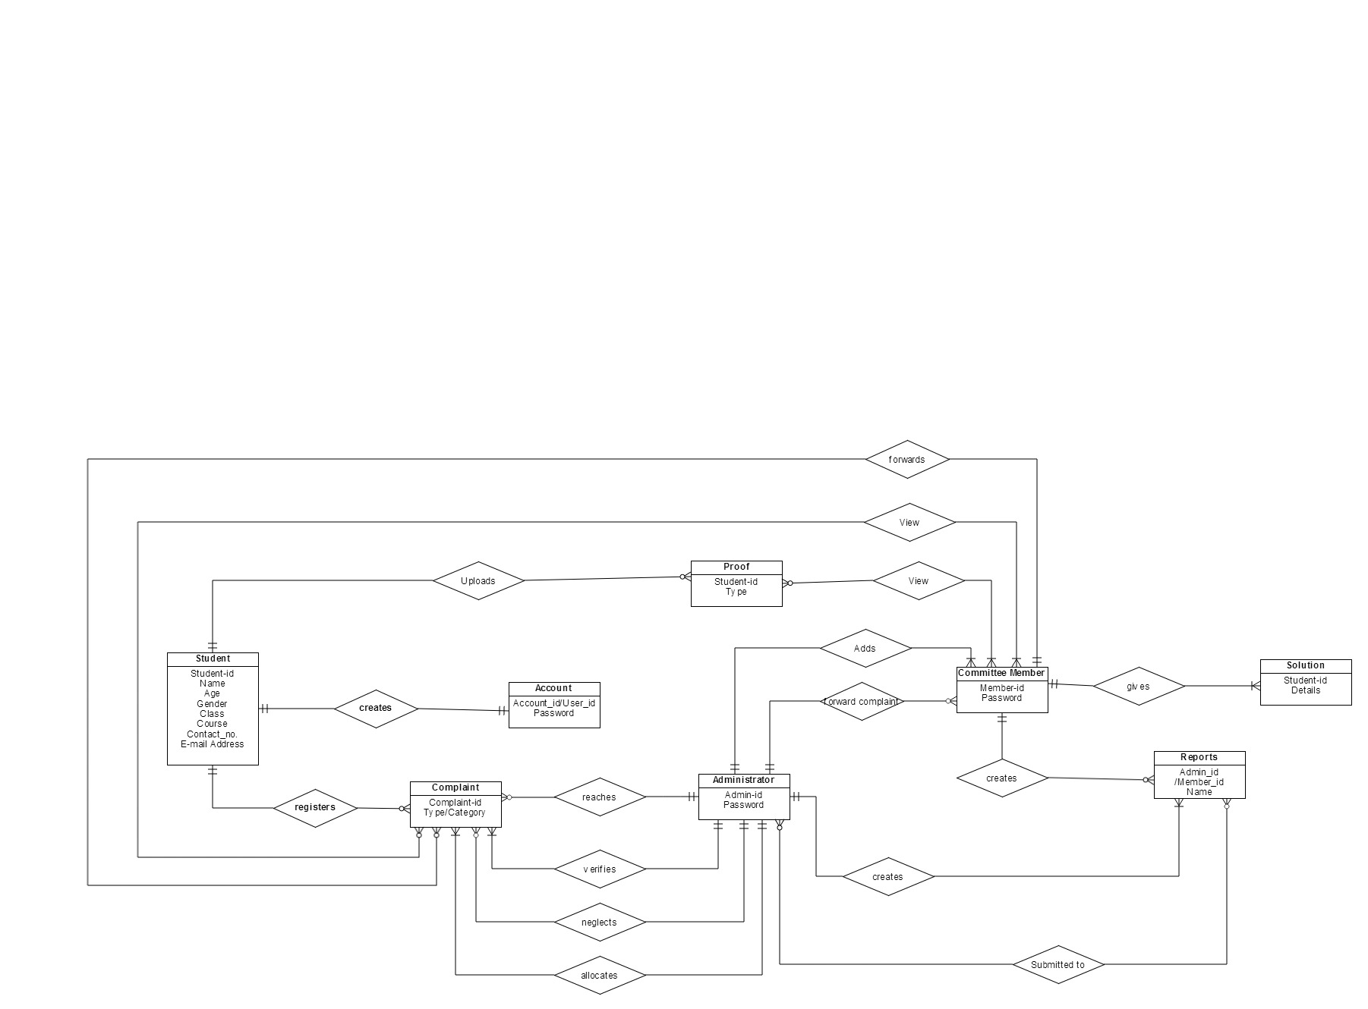

7. IMPLEMENTATION
7
IMPLEMENTATION

IMPLEMENTATION

Implementation is the process of converting the new designed system into the operational one. There are various types of implementation. Some of these are as follows:

- Implementation of a computer system to replace a manual system .
- Implementation of a new computer system to replace an existing system.
- Implementation of a modified application to replace an existing one.

We are following the first implementation method to implement our system. In implementing our system, we do not need to give very hard user training.

For conversion, we will use the parallel system method. The old system and the new system will be in operation simultaneously. This will provide the greatest security.

The new system will be implemented fully after sometime on the basis of feedback given by the user (here, users are victim, administrator and committee members).

9. TESTING

9

TESTING

Testing should be done throughout the implementation process. Even before an application is installed, it makes sense to verify that the basic platform is capable of achieving its design capabilities. System testing is a critical process. Testing is a process of executing a program with the explicit intention of finding errors that is, making the program fail. This help in finding the bottlenecks in the system. Executing a program in a simulated environment performs testing. The feedback from testing phase generally produces changes in the software to deal with errors and failures that are uncovered.

9. 1 Black box testing:

In Black Box testing or functional testing test cases are decided. Test cases are decided on the basis of the requirements or the specifications of the program or module.

Black Box testing is done in the project to remove the errors:

- Incorrect or missing function.
- Interface errors.
- Errors in data structures or external database access.
- Behavioral or performance error.
- Errors in initiation & termination.

9.2 White Box testing:

The White Box testing or Structural testing performs close operation of procedural details. They test the software logical path by having test cases exercising specific sets of conditions and loops.
White Box testing is done in the project to remove the errors.

- All modules path have been exercised at least once.
- Exercised on logical decisions.
- Executed all loops at their boundaries and within their operational bounds.
- Exercised internal data structure to ensure their validity.
9.3 Unit Testing:

Unit testing focuses on verification efforts of the smallest grid of software designing i.e. a software component or module is tested. This testing is done at the coding phase. This testing uses procedural design as guide to test major controls path and uncovers errors within the module boundary.

Following tests were performed during unit test:

1. Module Interface Testing:
Module interface was tested to ensure information flow in and out of the program unit.

2. Local Data Structure Testing:
Local Data Structure were tested to ensure that data store temporally maintain their integrity during all steps in algorithm execution.

3. Boundary Condition Test:
Boundary Conditions were tested to make sure that the modules operate properly at boundaries.

4. Independent Path Test:
All independent paths through control structure were checked to make sure that all statements in a module have been executed.

5. Error Handling Path Test:
Error handling path test was performed to handle exceptions.

9.4 Integration Testing:

Integration testing is done to tackle the problem of interface i.e. putting all the interfaces together. When the separate modules are put together and work in an integrated manner, this testing is performed. This testing is a Systematic technique. This testing is performed to check that data should not be lost across an interface. The objective is to take unit tested modules and build a program structure that has been dictated by design.

Regression: Regression was done to ensure proper working of each module with the whole system. Each module was embedded in the system and the whole tested for integrity.

9.5 System Testing:

System testing is done when the entire system has been fully integrated. The purpose of the system testing is to test how the different modules interact with each other and whether the system provides the functionality that was expected.

Security: Security was added to the system by making it password protected.

10. FUTURE PROSPECTIVE

10 10

FUTURE PROSPECTIVE

The project can be further expanded to many levels as:-

- A mobile application of Student Support System can be made.
- All the notifications must be received by the users(i.e., victim, Administrator and committee members) on their mobile phones.This will increase the rate of problem solving.
- A 24*7 toll free helpline for victims to lodge complaints.
- Audio and video proofs can be uploaded on the website as well as on the mobile application with complaints.
- Authentication process can be made much powerful by adding more security features so that fake complaints can’t be filed.
- A tracking system can be introduced which can help victim to track the current /latest status of his/her complaint.

